

Python Micro Project

Title :- Password Authentication

Batch: 19

* M.Avinash

(227Y5A0512)

* B. Parvathi

(217Y1A0598)

* R.Rakendra Shiva

(217Y1A05A9)

**Password Authentication**

ABSTRACT

A password authentication system is a system that is used for the identification of a user. Think of it like a login screen that you see while logging in to your Facebook account. It asks for your email or a username and then it asks for your password. If you have entered the correct password then it verifies you as the real user.

Creating a logic-based password authentication system. So, in the section below, I will take you through how to create a password authentication system using Python.

**Password Authentication Using Python**

To create a password authentication system using Python you have to follow the steps mentioned below:

* Create a [**Dictionary**](https://thecleverprogrammer.com/2020/12/31/python-dictionaries-tutorial/) of usernames with their passwords.
* Then you have to ask for user input as the username by using the input function in Python.
* Then you have to use the getpass module in Python to ask for user input as the password. Here we are using the getpass module instead of the input function to make sure that the user doesn’t get to see what he/she write in the password field.

So, let’s follow the steps mentioned above to steps:

**Implementation**

* + Technologies Used: Python 3.10.
  + Language Used: Python

**Project Code:**

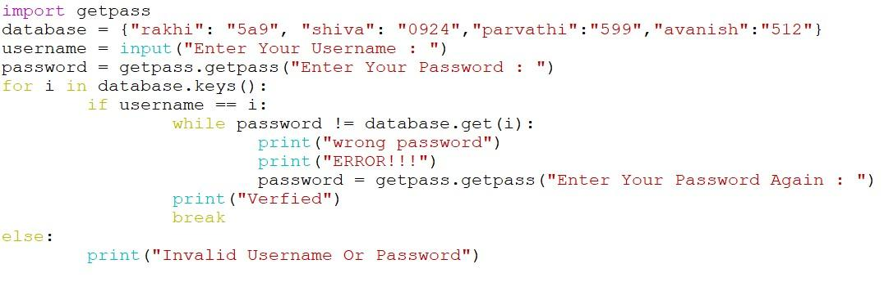

**Output:**

**Case: 1**

If Username Is Valid and Password Is Valid.

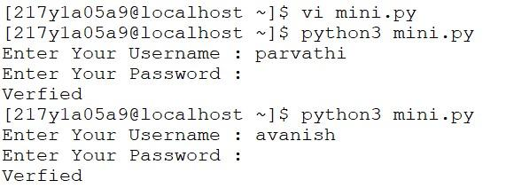

**Case: 2**

If Username Is Valid and Password Is Invalid.

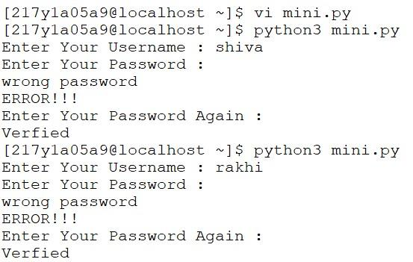

**Case: 3**

If Username and Password Both Are Invalid.

